Samples from North Jackson Elementary’s adapted Life Stories



I will Begin With the End in Mind when becoming upset. Ask myself: Will my actions help me get what I want?

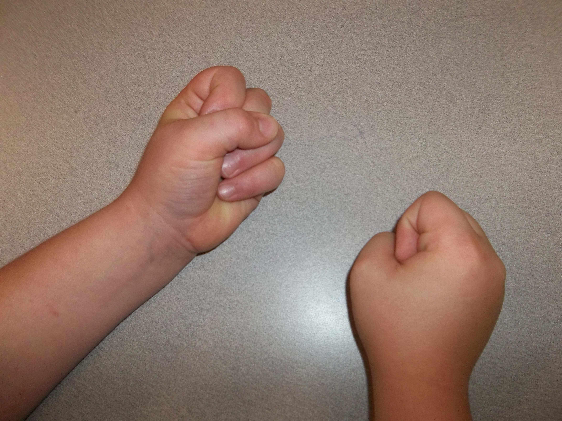

I will be Proactive. I will sit with my class in the gym and clap for others.

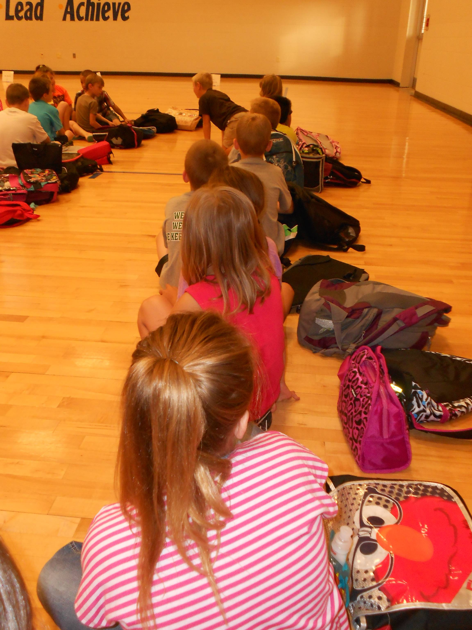

I will Put First Things First by thinking about the work on my desk first and think about the other things later.

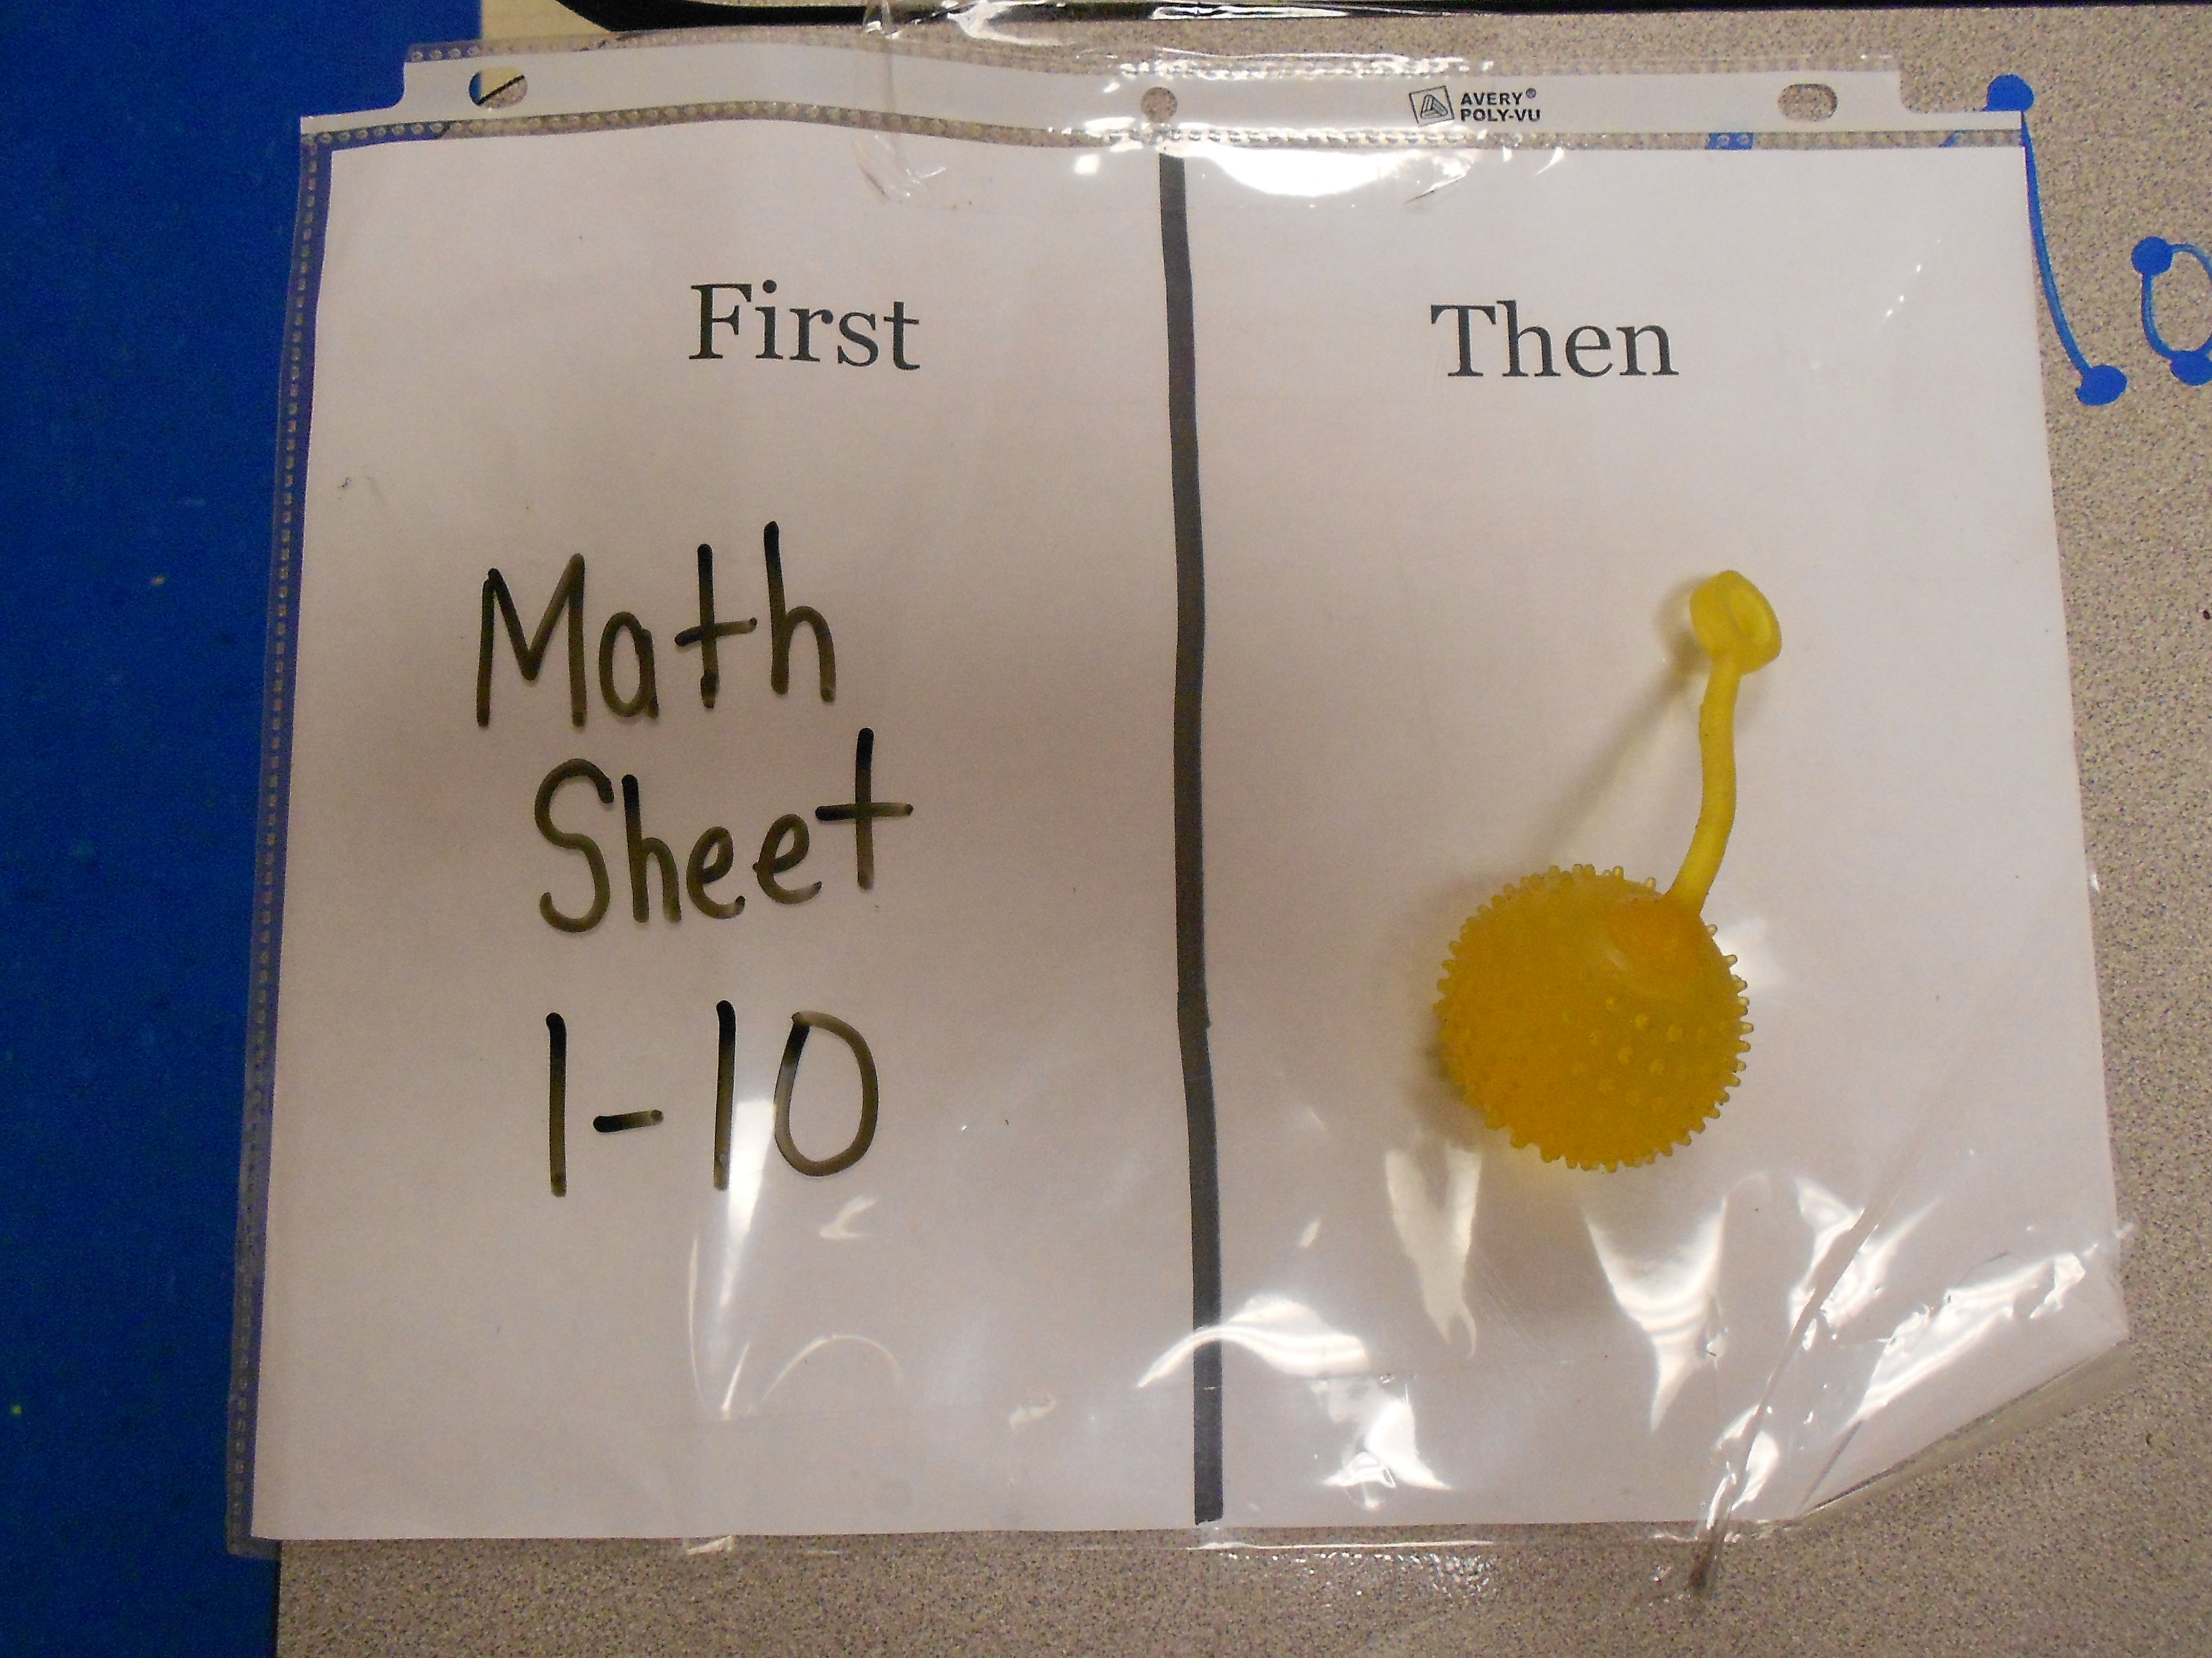
When I take turns swinging, I get to swing and so do my friends.
That is Thinking Win-Win!



